**Revision History**

|  |  |  |  |
| --- | --- | --- | --- |
| Revision number | Revision Date | Summary of Changes | Author |
| 0.1 | 2015/05/29 | * Initial Version |  |

**Content Summary**

1 Introduction to ELSA System 4

1.1 General description of ELSA 4

1.1.1 AP 4

1.1.2 Router 10

1.1.3 End Device – ESL Tag 11

1.1.4 End Device – SARA 11

1.2 Application Architecture 12

2 System Prerequisite 13

3 Install ELSA Web Management System 13

4 Function Descriptions 13

4.1 Tags and Product Associations 13

4.1.1 Associate Tags from Web Page 14

4.1.2 Associate Tags from BC page using Handheld 15

4.1.3 Associate Tags with SARA 15

4.1.4 Import/Export Associations from a file 16

4.2 Remove Product from Tag (De-association) 16

4.2.1 De-association Tags from Web Page 16

4.2.2 De-association Tags BC page using Handheld 17

4.2.3 Import De-associations from a file 17

4.3 ESL Tag Update and Job Control 17

4.3.1 Update Tag from Web Page 18

4.3.2 Update Tag from BC page using Handheld 18

4.3.3 Update Tag with Image 18

4.3.4 Job Status and Retry Mechanism 19

4.4 Tag Management 19

4.4.1 Device connection status 19

4.4.2 Device Information 20

4.5 Inventory Management 21

4.5.1 Add Inventory 21

4.5.2 Edit Inventory 23

4.5.3 Remove Inventory 24

4.5.4 Backup to File 24

4.6 Layout Management 24

4.6.1 Associate Layout 25

4.6.2 De-associate Layout 25

4.6.3 Add New Layout 25

4.6.4 Edit Layout 26

4.6.5 Generate Layout Preview 26

4.6.6 Remove Layout 26

4.6.7 Backup Layout Profile 26

4.6.8 Import Layout Profile 26

4.6.9 Remove Selected Profile 27

4.7 System Inspection and Diagnostic 27

4.7.1 System information 27

4.7.2 Email Report and Notifications 29

4.7.3 Show Device’s History 30

5 Customization – PP 30

5.1 Products Information 32

5.2 Association Information 32

6 Trouble Shooting 33

7 Web Page Illustration(Map) 33

7.1 Common Panel Explanation 33

7.2 Site Map 35

7.2.1 Dashboard 35

7.2.2 Inventory 35

7.2.3 ESL Management 36

7.2.4 Layout 37

7.2.5 Installation Wizard – Device registration 38

Below is the installation wizard - device registration page explanation 38

7.2.6 Installation Wizard – Waking-up tags 39

8 Contact Information 40

# Introduction to ELSA System

## General description of ELSA

ESL(electronic shelf label) system is now popular way to change product price and information by retailers. ELSA is the ESL system designed by M2Comm, focusing on small and medium size of shopping store ranging from hundreds to thousands of tags. The communication model used in the ELSA is the M2Comm’s proprietary protocol named Platanus. The Platanus Network consist of 3 major device types, AP, Router and devices and with an application-specific back-end program. In the ELSA System, a Web-based application is developed as the back-end program and also with a customized application PP (Preprocessor) to fulfill different integration interfaces.

### AP

The Platanus AP is in charge of forming the Platanus network and connects to IP network through its ethernet interface. In ELSA, AP needs to communicate with the back-end program before it could start a Network, and the SOP is defined in ELSA to maximize the system stability refer 9 for details.

AP’s jobs include:

* Construct the whole network by periodically beacon interval.
* Manage the network resource (all device table).
* Accept the requests from Back-end Prorgram.
* Forward the network responses to Back-end program.

#### Network Capacity

The Network capacity is defined by the mode AP runs in. The following table shows the current adapted settings used in ELSA. In the table, Max Number per AP is the real tested number, up to 20 % more devices are possible but with high stability risks.

|  |  |  |  |
| --- | --- | --- | --- |
| Mode | Max Number of per AP | Max Number of Tag Updated per Hour | Note |
| Best Performance | 6000 | 10800 | Default |
| Best Capacity | 12000 | 6700 | (In-Testing) |

* Max Number of Tag Updated per Hours is measured by the small image updates and best RF status.

#### Basic Configuration of AP

AP’s default AP address is 192.168.2.1. In some case, user might have to change the IP address of AP using device finder.

* **Device Finder**

Device Finder is application software which can offer to configure AP’s IP address/Subnet Mask/Gateway IP.

**Step 1:**

* Install “DeviceFinder_Setup_v101.exe”.

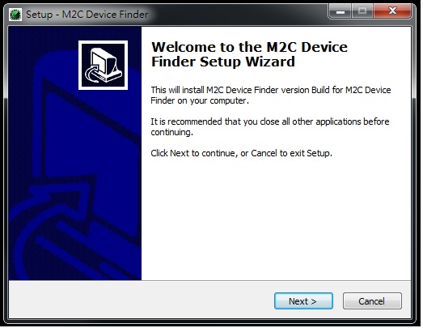

* Setting specify the installation path or using the default path(Recommend).

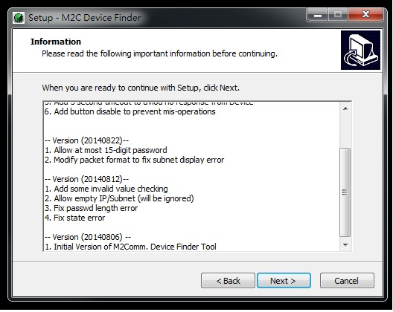

* Setting specify the installation path or using the default path(Recommend).

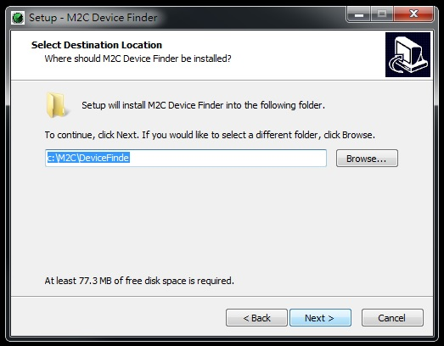

* Whether create desktop icon or not

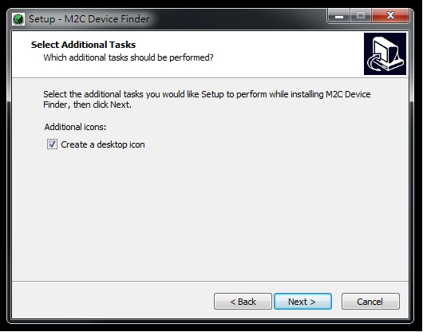

* Installation is finished.

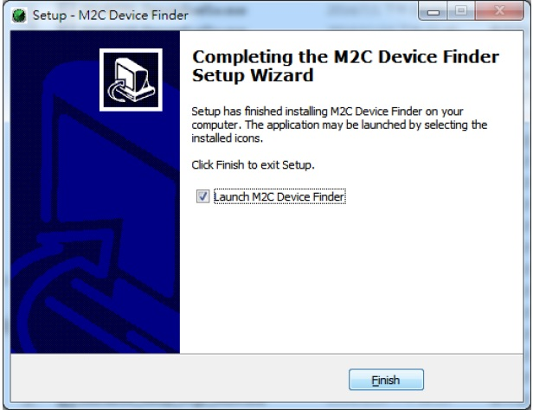

**Step 2:**

* Execute “M2C Device Finder” in desktop.
* User press “Refresh” button can find out all available APs information in the same subnet

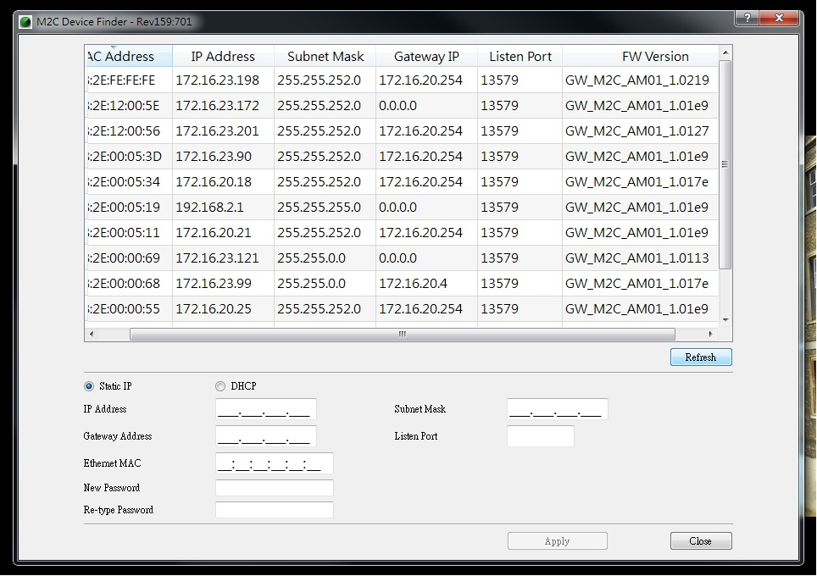

* Choose specify AP entry from list and enter password.(*Default password is 1234)

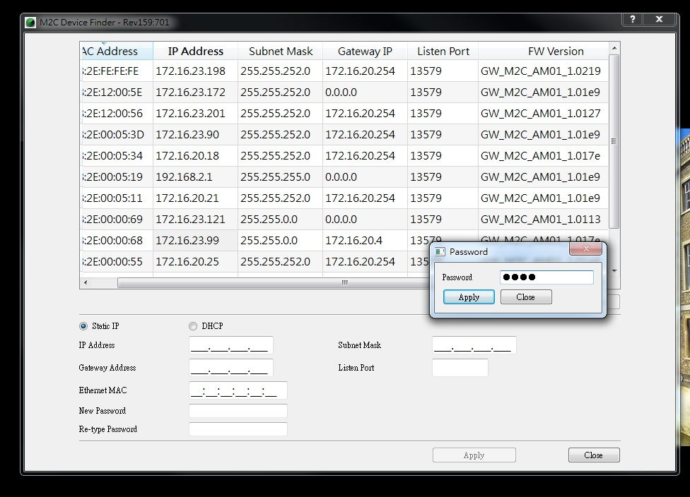

* Choose specify AP entry from list and enter password.(*default password is 1234).

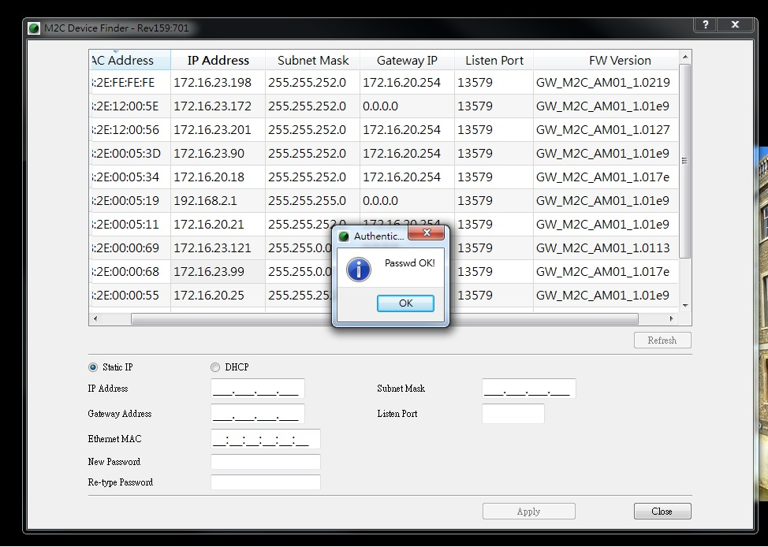

* Specify new setting for AP and press “Apply”.

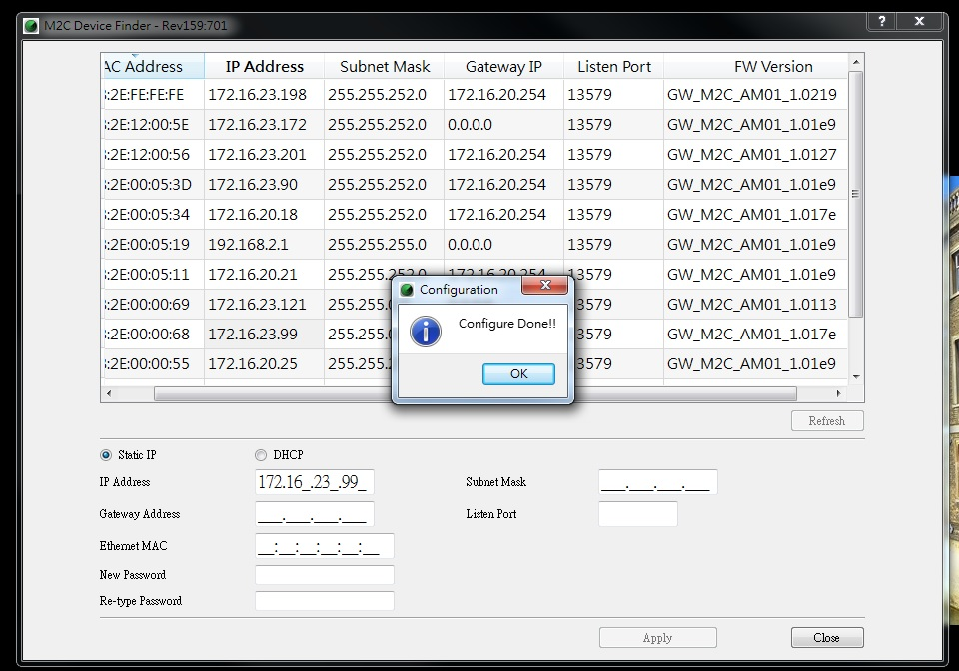

* Press “Refresh” can see the new setting are accepted already.

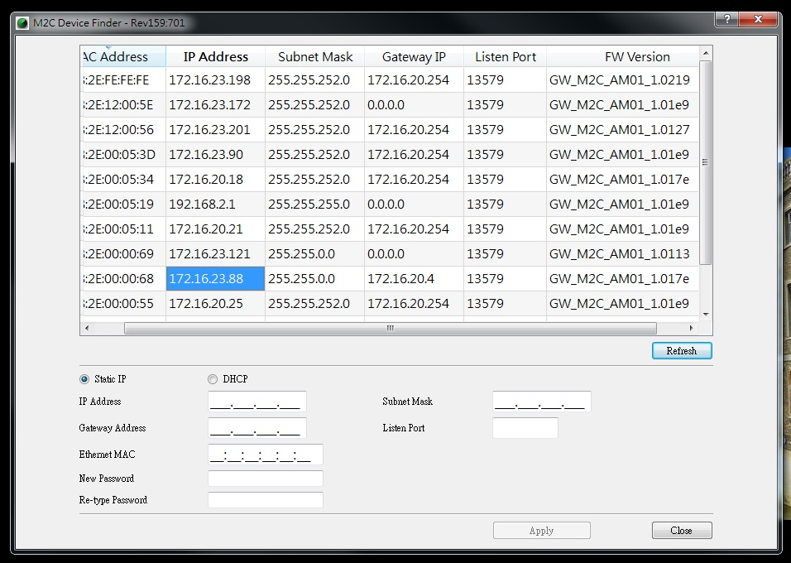

#### LED Behavior

In the AP, there are two LEDs indicates the current status and USB is only for power supply.

Besides, AP whether enable send beacon or not control by daemon.

|  |  |
| --- | --- |
| LED | Behavior |
| Green LED | Power Indication |
| Blue LED | Enable/Disable send beacon indication  LED flashing: AP forbid device joining.  LED on: AP allow device to join. |

#### Channel Scanning

AP offer channel scanning function to sense current environment. It can help user choose the best channel to use in the installation mode. Channel scanning turn on/off control by daemon.

### Router

Router is powered by 5V-mini USB cable and has only Platanus RF interface. Router always joins to the nearby AP and need user’s confirmed in ELSA installation phase.

In Platanus Network, RT is an important component. RT’s jobs include:

1. Forward data link from AP to ED.
2. Store the Uplink Notify from ED and forward to AP reliably
3. Accept the join requests and manage the device information.
4. Extend the network coverage and capacity.

#### Router Capacity

In Platanus, each standard RT could allow up to 1000 end devices (EDs) to join but the capacity defined in ELSA system for each RT is 800. In real environment, there will always be devices connected to the ‘not as good’ RTs due to interference or shielding. Platanus is designed to allow device re-connect for better RTs. The principal is to provide extra capacity for those ‘not good’ devices so the minimum number of RTs per system is 2 and the capacity defined is 80% of the maximum number of possible devices.

|  |  |  |
| --- | --- | --- |
| Max Number of Devices per RT | Capacity | Note |
| 1000 | 800 | Default |

According to the capacity rule, one extra RT is required for every more 800 devices. The following table shows some example..

|  |  |
| --- | --- |
| Total number of  EDs | Minimum Number of RTs |
| 1000 | 2 |
| 2500 | 4 |
| 3500 | 5 |
| 6000 | 8 |

#### LED Behavior

In the RT, there are three LEDs indicates the current status and USB is only for power supply.

|  |  |
| --- | --- |
| LED | Behavior |
| Green LED | Power Indication |
| Red LED | Error indication |
| Blue LED | Enable/Disable join indication |

### End Device – ESL Tag

In Platanus Network, ED is to display product price and information. Besides, it can receive and execute request from user by Web GUI, return result relatively.

### End Device – SARA

The main function of Platanus SARA is connected between ED and product information. It can help user program or Web GUI managed all EDs current product price status.

#### SARA Interface

There are two buttons and three LEDs to control user’s operations and display current status in SARA.

Below is SARA picture and interface explanation:

**Association Button**

**Control Button**

**Green / Blue/ Red LED**

**Scan Area**



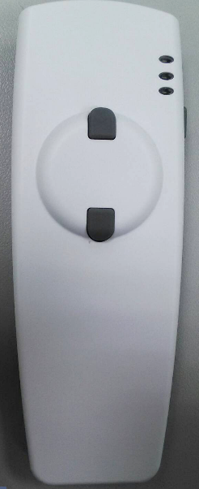

* Button behaviors

|  |  |
| --- | --- |
| Button | Behavior |
| Control button | Long press to turn on/off SARA  LED is on if mac address format |
| Association button | Associated ED and product |

* LED behaviors

|  |  |
| --- | --- |
| LED | Behavior |
| Green LED | * LED is off in Power-off mode * LED is flashing when searching for network * LED is on in Ready-mode(camping on the network |
| Red LED | * LED is on if mac address format error/product code isn’t support |
| Blue LED | * LED is flashing to accept mac address * LED is on standard for send out association data to RT |

#### SARA Status mode

In SARA, there are three main status mode can control by user:

* **Power-on mode**

User long-press control button turn on SARA. Green LED is flashing, user can do anything in Power-on mode. Need to wait for SARA camping on network.

* **Ready mode**

SARA in ready mode, green LED is on and camped on network already. User can start to associate product with ED in this mode.

* **Sleep mode**

If SARA in ready mode and user do nothing more than 10 second, SARA will enter sleep mode and all LEDs will turn off. User can press control/association button to wake-up SARA let it back to ready mode.

## Application Architecture

ELSA web management system consists of three important components which are Image Creator, layout and PP.

Image Creator is used to generate image from product info which will be shown to ESL. The generated image is pdu file.

Layout is used to define the places of product’s information in tag for instance where to put product’s name, what is the font-size to be used for price, etc.

PP is used as the data converter from third party application for products or association information that will be discussed more detail in here.

Figure below is the explanation for the relations between PP, layout and image creator

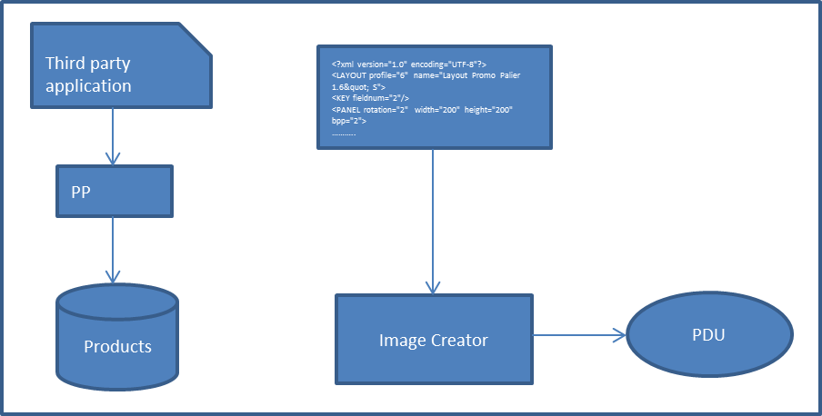

# System Prerequisite

PC and OS Reqruirements

location of ethernet plug, power plug..

Configuration of AP Ethernet MAC

Interference Check, etc

# Install ELSA Web Management System

# Function Descriptions

After the system is installed, there would be a list of on-line tags shown from Web. These tags need to associate with products to display the product information.

## Tags and Product Associations

In ELSA 1.0, each ESL Tags must be associated to one Product before it could be updated. There are several methods to associate the ESL Tag to a product, listed below. In any case of the association method, the Tags should be automatically updated with associated image:

Example:

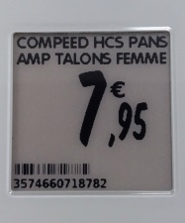

### Associate Tags from Web Page

Click on the ESL Management Page and follow the steps:

1. Double click one of the tags from the list. Only “TAG” can be associated.

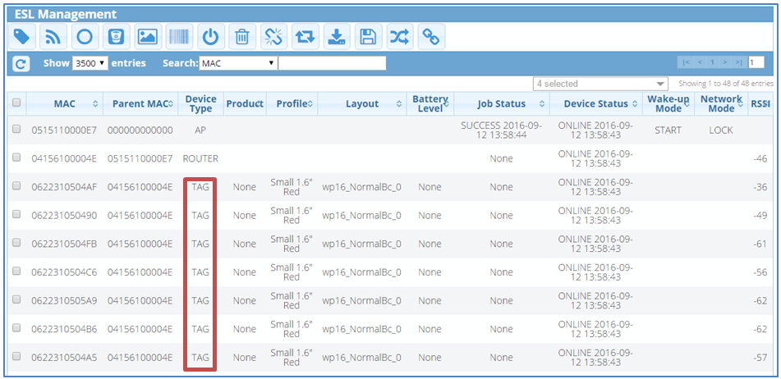

1. The window like below will appear. Click on the pencil icon to choose the product.

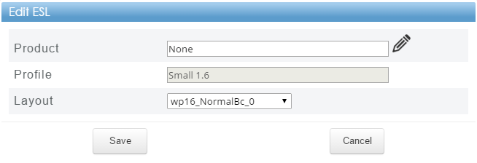

1. After the list of product like below appears, you can choose the product and click “Select”.

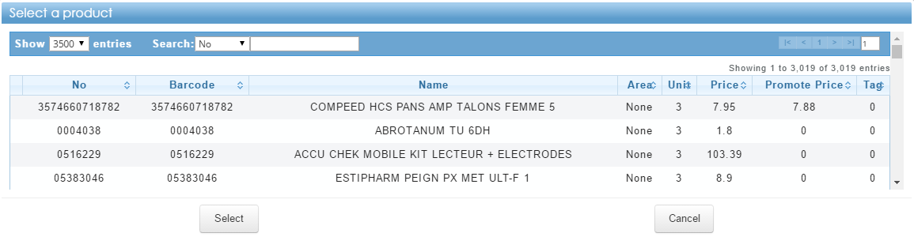

1. After choosing the product, the window like below will appear. You also can change the layout in this step. If everything has been chosen correctly you can click “Save” and the tag will update its information with the newest data.

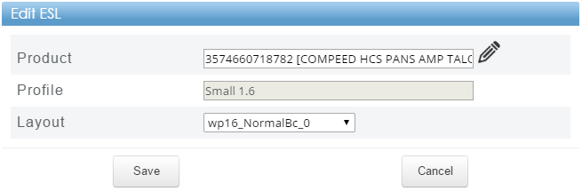

1. From the list, you can notice the product has been changed

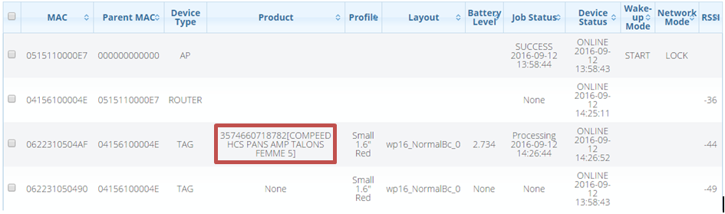

### Associate Tags from BC page using Handheld

The BC page is a specific page designed for limited resolution devices and it’s used by handheld scanner.

Follow the instruction below to access “BC” page:

1. On the “ESL Management” page, Click icon  or go to http://”server_ip”:88/en/esl/bc. The window like below will appear



Number of failed job

Selection

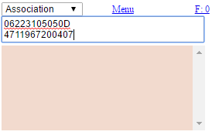

Input box for scanning

Action’s log

1. Choose “Association” from dropdown list
2. Scan MAC address of tag followed by scanning product’s barcode
3. Tag should update its image immediately
4. In case PostgreSQL is used and need update product information from third party application, you need to click “Sync” button on the menu

### Associate Tags with SARA

.

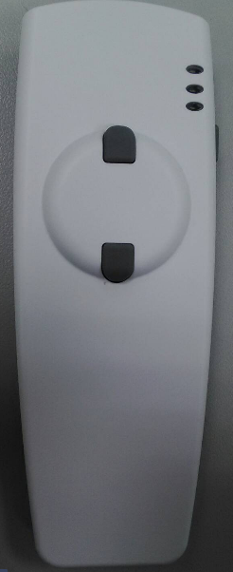

LED

Association button

Power button

1. Power on the SARA
2. When SARA is ready, point the scan area toward tag’s MAC address then click association button
3. If scanned data is correct MAC format, blue LED will blink, otherwise red LED will turn solid to notify user the scanned data is wrong

|  |  |
| --- | --- |
|   NOTE | If you see red LED, click power button to cancel the association. Afterward, red LED will turn off |

### Import/Export Associations from a file

You can also update the tags-products association by importing the file through web. Follow the steps below for import the association data

1. Go to ESL management page
2. Click button 
3. Choose csv file with format specified in here. Make sure the action is “A” and file should be saved as a csv file.

## Remove Product from Tag (De-association)

De-association is used when you want to remove product from tag. By doing this, tag will not show product information and will be shutdown to save the battery. Like association, it has some ways to de-associate the tag from product

### De-association Tags from Web Page

Follow the steps below to de-associate the product from tag

1. Go to ESL management page

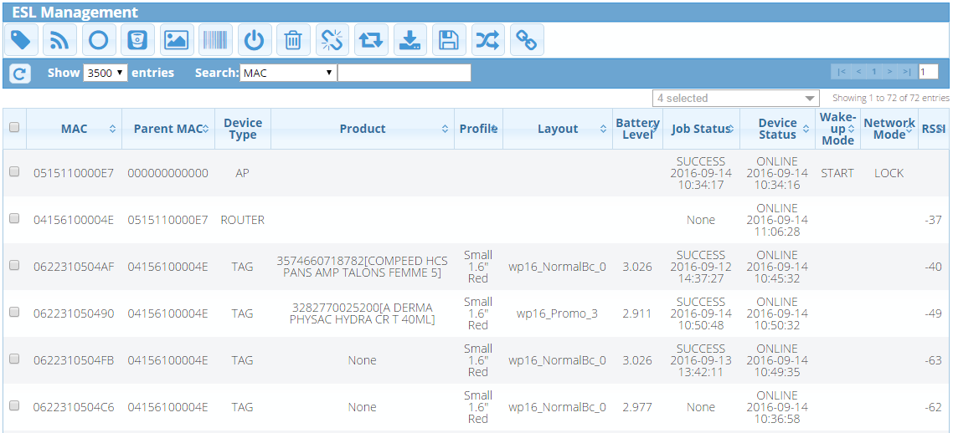

1. Check the tags want to be de-associate
2. Click icon  and confirm the confirmation
3. As a result, you can see the product info will be “None”.
4. And from the tag (device) itself, it will be shut down and show the barcode.

### De-association Tags BC page using Handheld

You can also de-associate the tag from BC page using handheld device by selecting “Deassociation” on the option and scan the tag’s MAC address like shown on the image below.

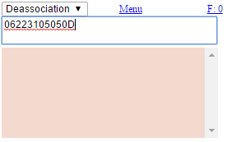

### Import De-associations from a file

You can also de-associate remove the product from tag by importing the file through web. Follow the steps below for import the ade-association data

1. Go to ESL management page
2. Click button 
3. Choose csv file with format specified in here. Make sure the action is “D” and file should be saved as a csv file.

## ESL Tag Update and Job Control

The Tags information update from PP is not included here, refer to customization.

### Update Tag from Web Page

Sometimes, the process of updating tags will fail, this probably due to instability of network or other reasons. In this case, it’s needed to update the tag with current product information associated on it. Follow the steps below to update the tag from web page

1. Go to ESL Management page
2. Check the tags want to be updated
3. Click icon 

### Update Tag from BC page using Handheld

You can also update the tag from BC page using handheld device by selecting “Push” on the option and scan the tag’s MAC address like shown on the image below.

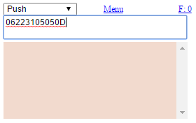

### Update Tag with Image

Beside product information can be shown on tag, tag also can show external image in it. Follow the steps below to show an image on tag.

1. Go to ESL management page
2. Check the tags you want to show the image
3. Click icon 
4. The window below will appear. Choose the image file and the preview will appear

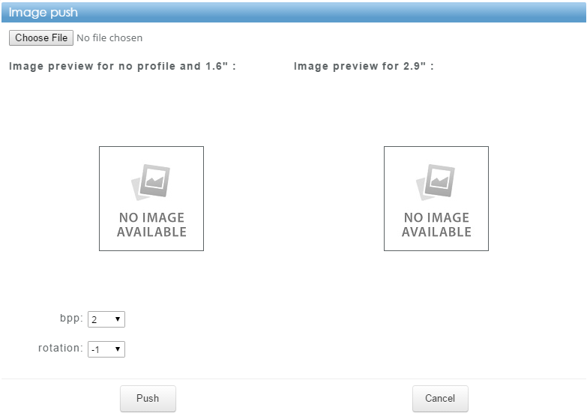

|  |  |
| --- | --- |
|   NOTE | *Parameters for bpp:*   * *1 for tag with black and white profile.* * *2 for tag with black, white and red profile*   *bpp can only be used by admin or SA* |

1. When the image and setting are ready, click button “Push” and tag will be updated

### Job Status and Retry Mechanism

## Tag Management

User can check tag’s status in the ESL Management page. Status is divided into 4: Online, Offline, Connecting and Not Registered.

* Online: Tags are available in system.
* Offline: Tags are unavailable in system.
* Connecting: Tags are waiting for confirming (in installation).
* Not Registered: Tags are not in associate list or didn’t receive link report from this tag (in installation).

Battery level and tag’s RSSI value are also shown in ESL Management page. User can monitor the battery of the tag by battery level column and check the tag’s location is god or not by RSSI value.

* RSSI value above -60: good.
* RSSI value -61~-70: acceptable.
* RSSI value lower than -70: weak.

### Device connection status

Tags show ONLINE after installation and change to OFFLINE under the following situation:

* AP/RT disconnects.
* Query timeout.
* Shutdown/Reboot tags.
* Receive ED_NOT_FOUND in job report.

Query is used for updating the tags status and RSSI value. If job to tag(s) fail continuously, you can use query to make sure tag status. To query the devices, check the item(s) that will be queried then click icon. System will auto query all tags at 8 A.M. every day.

If user wants to let tags rejoin the network (maybe RSSI bad or something else), click icon  to reboot the tags. Device status of queried and rebooted devices will be OFFLINE, and return back to ONLINE later once web receives link report.

When you see the tags are shutdown or still OFFLINE after query it. You can turn it on by using wake-up function. The function can be triggered by check the “AP” and click icon. Change wake-up mode will change mode into opposite mode. If current mode is STOP, this will change to START and vice versa. If user forgot to stop the wake-up function, system will auto stop wake-up mode after 30 minutes.

Sometimes you need to remove the devices from network. This is probably caused by some reasons such as broken devices or unnecessary devices.

You can follow the steps below to remove the tag(s)

1. Check the item(s) that will be removed then click icon 
2. Click “OK” on the confirmation.

### Device Information

As mentioned above, user can check the tag’s RSSI value in ESL Management page. If some tag’s RSSI value is not good, try rebooting the tag to force it rejoin the network or add another RT for RSSI bad area.

It is important to easily notice tags with low battery voltage. Here, you can set the threshold for low battery. Battery level of each tag is lower than the value set in battery threshold will be shown in red color. Besides, set “Max battery level to use low battery layout” in the Maintenance – ESL Settings page will push the low battery layout and display no battery image in battery level column if the battery is under the configuration.  
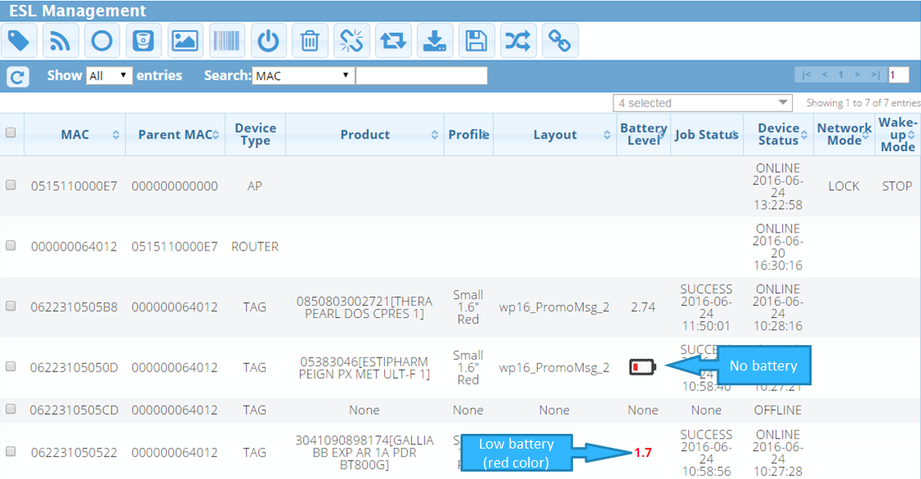

To set the low battery threshold,

1. click icon  and the window like below will appear.

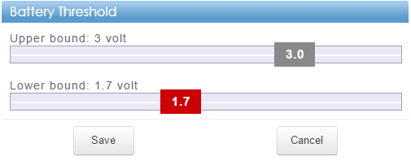

1. Set needed lower bound and click “Save” after finish.

To set the Max battery level to use low battery layout:

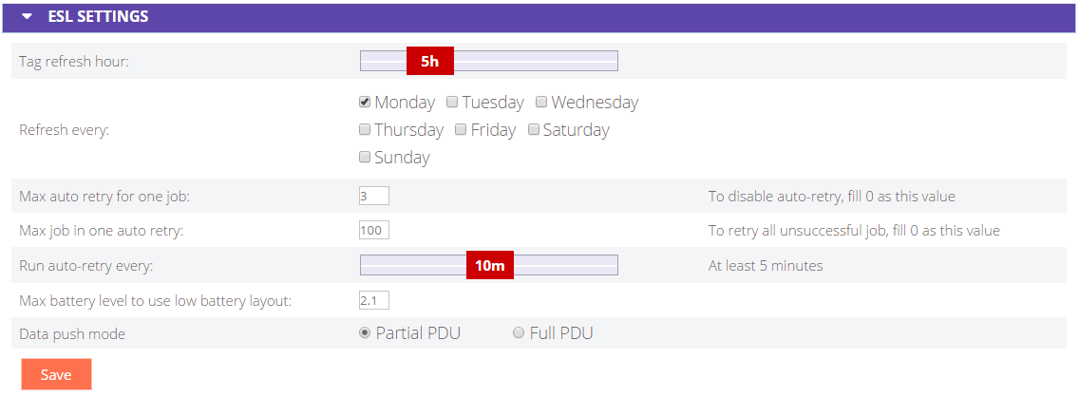

## Inventory Management

After you know how to manage the devices, you need to know how to manage your inventory in ELSA 1.0 because the tags information comes from inventory.

The actions in this section are on the “Inventory” page.

### Add Inventory

You can add new inventory into the system by two ways

#### Add new product from Web page

1. Click Icon  and window like below will appear.

Each item represents:

**No**: Product number

**Barcode**: Barcode number

**Name**: Product name

**Area**: Country or area where is it made

**Unit**: It can represent weight, length, or capacity

**Price**: Product price

**Promote** **price**: Price on sale

**Custom** fields: User definition

**Layout** **index**: Input different layout number to fix this product with its specified correspondent layout. If this column leaves in blank, it represents no fixed layout.

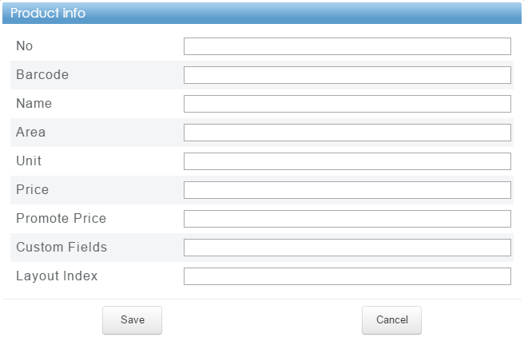

1. Input needed information then click “Save”.

|  |  |
| --- | --- |
|   NOTE | * *No (number) can be duplicated on database but not for barcode* * *When you use “Layout Index” for this product, the tag associated with this product will use layout index associated to tag’s profile. We will discover this in “manage layouts” later* |

#### Import Products from CSV

If you have a list of inventory, you can save the file with csv format and import it into ELSA web management system.

Follow the steps below to import the inventory.

1. Click icon  then the window like below will appear.

* Choose the file by clicking “Choose File”. The file should be on CSV format.
* Click “Import” when file is ready.

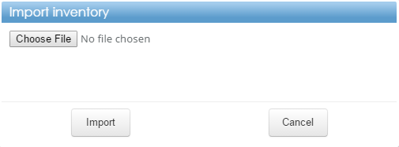

#### Below is the CSV format for importing product.



|  |  |
| --- | --- |
|   NOTE | * *Layout here is “layout index” same like adding inventory above.* * *Action can be “M” which means modify or insert and “R” which is remove the inventory* * *Tag associated with modified product will be updated* * *Tag associated with removed product will be deassociated* |

### Edit Inventory

Sometimes you need to update the inventory. Follow the steps below to edit the inventory manually

1. Double click the product on the list. The window like below will appear.

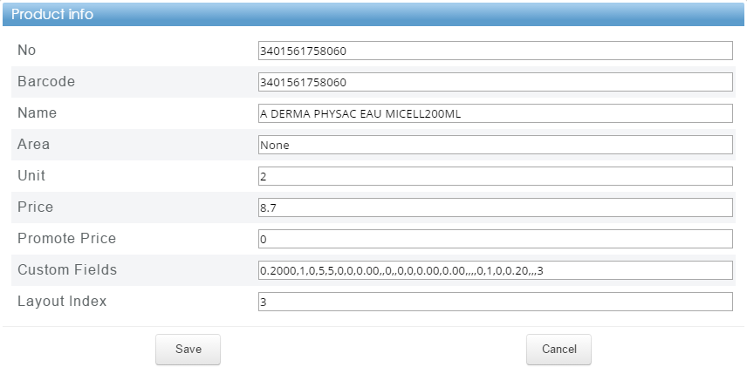

1. Edit needed information then click “Save”.
2. As a result, tags associated with this inventory will be updated.

|  |  |
| --- | --- |
|   NOTE | *As mentioned above, by importing list of inventory you can also edit the inventory by placing “M” as an action following the information of changed inventory based on barcode* |

### Remove Inventory

When inventory is no longer be used, you can remove it from ELSA 1.0 web management system. Follow the steps below to remove the inventory

1. Check the item(s) that will be removed then click icon 
2. Click “OK” on the confirmation.

|  |  |
| --- | --- |
|   NOTE | *As mentioned above, by importing list of inventory you can also remove the inventory by placing “R” as an action following the information of removed inventory based on barcode* |

### Backup to File

If you want to backup inventory data, you can use “backup to file” feature by clicking icon  and csv formatted file will be downloaded to local computer.

## Layout Management

Layout is really important part for tag. It defines the places of information in tag for instance where to put product’s name, what is the font-size to be used for price, etc. In this topic you will know how to manage the layout you want to use.

Collection of layouts

List of profiles

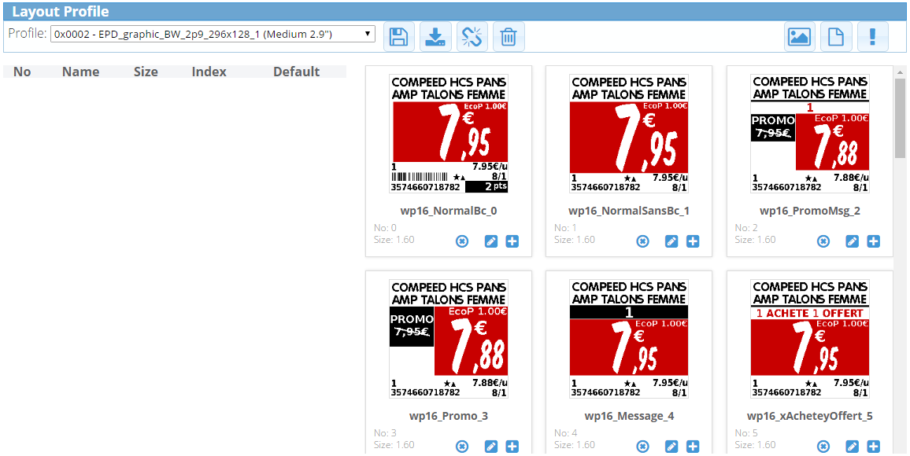

List of associated layouts here

### Associate Layout

For using the layout, first you need to associate the layout into the profile. Follow the steps below to associate the layout to profile

1. Choose the profile from the list
2. Click icon  at specific layout
3. If adding the layout is success, the left side of image above will be looks like image below

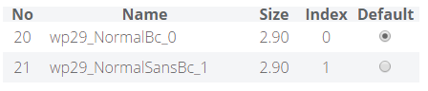

|  |  |
| --- | --- |
| ☝  NOTE | * *Do you still remember about “layout index” for product? The “layout index” refers to “Index” at the image above. Basically it just simply the order of layout association to profile* * *When you add layout, it will be added as a last index* * *You can change the index by dragging the layout to the targeted index* * *You can also set the layout as default layout for profile by click column “Default”* |

### De-associate Layout

In case you associated wrong layout and you want to de-associate it from profile, you can do it by double click the layout in associated list.

You can also de-associate all layouts from profile by clicking icon 

### Add New Layout

You can add new layout by click the icon  then the window like below will appear

**No**: Layout number.

**Name**: Layout name.

**Size**: Specify which tag size it belongs to, such as 1.6", 2.9", or 4.2".

**Layout**: Input the xml for layout design.

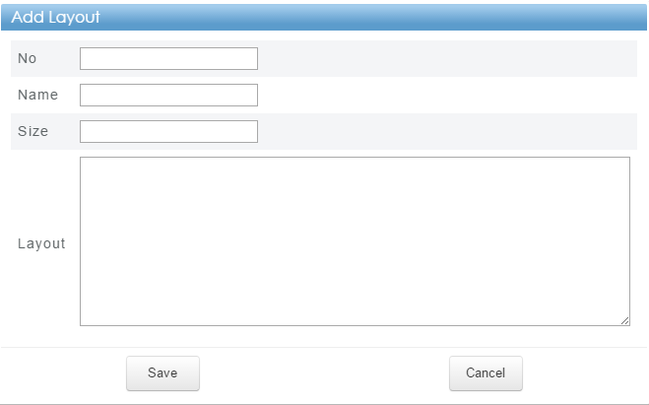

Input needed information and click “Save”

|  |  |
| --- | --- |
| ☝  NOTE | * *Layout is based on xml format* * *No and name cannot be duplicated* |

### Edit Layout

You can edit the layout by clicking icon  then the window like below will appear

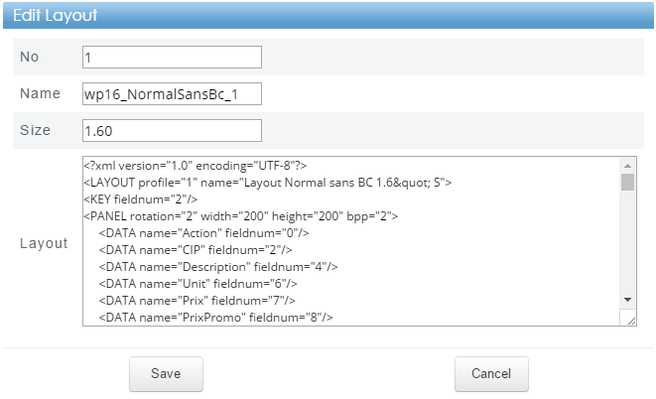

Edit the data and click “Save”

### Generate Layout Preview

If you don’t see the image under collection of layouts, you can generate the image preview by clicking icon.

### Remove Layout

If you want to remove unneeded layout, you can do it by clicking icon on the specific layout and confirm the confirmation.

You can also remove all layouts by clicking icon  and confirm the confirmation.

### Backup Layout Profile

If you want to back up the layouts and profiles including the associations, you can click icon  and zipped file will be downloaded into your computer.

### Import Layout Profile

You can also import the layout into the system by clicking icon  and window like below will appear

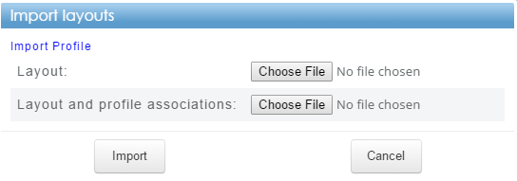

|  |  |
| --- | --- |
| ☝  NOTE | * *Click “Import Profile” to import profile* * *The input files are JSON file format* * *Same number or profile / layout will be updated* |

### Remove Selected Profile

You can also remove the selected profile by clicking icon . As a result, selected profile will be removed from list of profiles

## System Inspection and Diagnostic

### System information

The actions in this section are on the “System Overview” page

#### Access Point Information

In normal operation, connected access point is displayed like below.



Note:

1. *If there is no MAC shown on the information, it means AP is not connected with daemon*
2. *Sometimes firmware info is not shown but the status is connected. This is due to web gets the firmware info later after MAC information*

#### Network Summary

It shows number of items on database (product, AP, router, tag, profile)

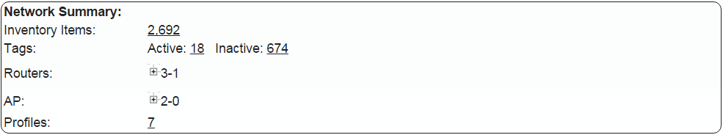

Note:

1. *Number of AP and router show active number followed by inactive number*
2. *Click sign + on AP or router for detail. Example is like picture below*

Active - Inactive

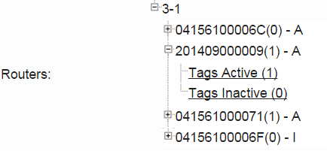

Number of Tag

MAC(tags join this router) – (A = Active; I = Inactive

#### Path Information

It shows the path information for database file log file and image creator

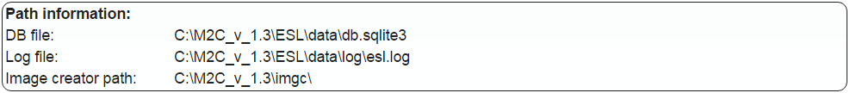

#### Log

Here shows the system log (esl.log).

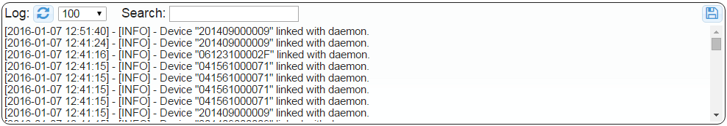

Note:

1. *Click icon*  *to retrieve logs from server.*
2.  *indicates maximum number of lines to show.*
3. *Type keyword on search box for searching on log.*
4. *Due to maximum showing is 2000 lines and logs are split into several files, click icon*  *to download the logs file for checking on local site.*

### Email Report and Notifications

ESL Web Management System has a feature for daily email report and notification.

• Currently notification supports:

◦ Unreachable tag due to auto retry

◦ Link report after unreachable.

• The email notification is sent before auto retry

#### Email Settings for Report

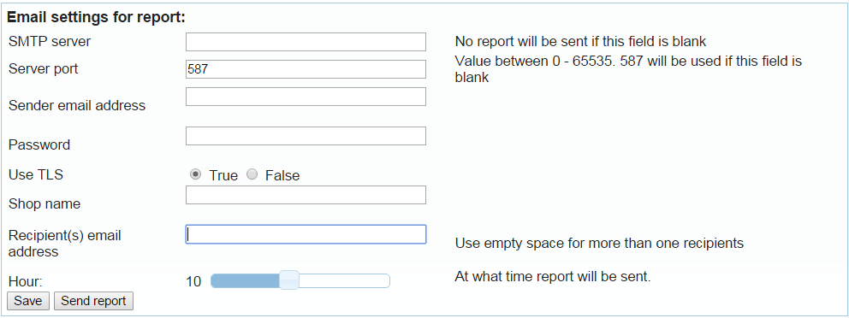

1. Input needed information then click save button.

2. After save, click “send report” for testing configuration is working properly or not.

### Show Device’s History

For debugging usage, you can check device history by clicking one device and click on the bottom right corner. Then tag’s history will be shown on small window like below.

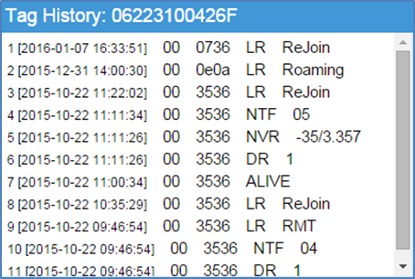

# Customization – PP

As you already know about ELSA system, now you may need to integrate ELSA system with third party application. Here we will explain more detail about PP and its data format that you can follow to create your own PP

Not all of third party application can generate the information with format above, hence PP is playing important role to match supplied data from third party application into web specified data format.

As every customers may have different schema for their products, it is important that PP deals with customer’s data and arrange them into the form that web can understand them.

Furthermore, due to the complexity of customer’s application, there will be different PPs for different customers. So one PP for one customer application, each PP will only process a certain schema for a certain customer.

**Overview:**

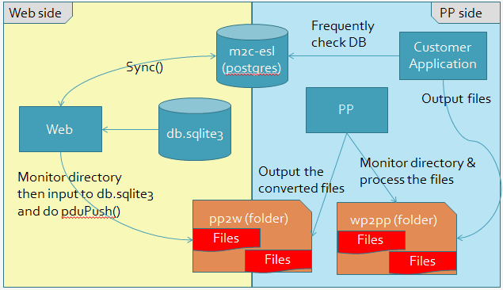

Basically, there are two stages that web involved interaction with pp.

Stage I:

At this stage, the main task for web is to sync database from web to customer database. On the other words, tags association information from web is synced to customer database.

Stage II:

At some certain conditions, either by manually or automatically triggered, customer application will generate a csv or ctrl file to web and web will update them into web’s database.

|  |  |
| --- | --- |
|   NOTE | *PostgreSQL part is an optional* |

## Products Information

Basically, ELSA web management system can process supplied csv file with the format described below.



|  |  |
| --- | --- |
|   NOTE | * *Action can be M for adding or modification and R for remove.* * *Layout is the layout index we already talked here* ***-> refers to layout index*** * *Custom fields related with layout* |

So, your PP need to provide the data that can be read by ELSA system with the format explained above and ELSA system will process this file under C:\M2C\EslWebSystem\pp\pp2w. Save the file as csv.

You also need to generate one more file beside that csv file which is the trigger file for ELSA system to read your csv file. The file name should be the same with your csv file and save that file with extension done.

Example:

Csv file: C:\M2C\EslWebSystem\pp\pp2w\123456.csv

Trigger file: C:\M2C\EslWebSystem\pp\pp2w\123456.csv.done

## Association Information

Beside products information, ELSA web management system can also process association information with following format

Action

MAC

Barcode

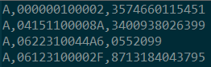

|  |  |
| --- | --- |
|   NOTE | * *Action can be A for association, D for de-association and R for remove the tags* |

* Save the file into C:\M2C\EslWebSystem\pp\pp2w with extension .ctrl

If you plan to use PP for generating association data, you need to generate the file like format explained about and put the file into C:\M2C\EslWebSystem\pp\pp2w. The extension of file should be ctrl.

You also need to generate one more file beside that ctrl file which is the trigger file for ELSA system to read your ctrl file. The file name should be the same with your ctrl file and save that file with extension done.

Example:

Ctrl file: C:\M2C\EslWebSystem\pp\pp2w\98765.ctrl

Trigger file: C:\M2C\EslWebSystem\pp\pp2w\98765.ctrl.done

# Trouble Shooting

# Web Page Illustration(Map)

## Common Panel Explanation

This section will explain ESL Web Management System panel which are used by some pages.



1. Checkbox  on the table header is for check all items.
2. Icon  is for revert current selection.
3.  is for setting maximum item to be shown.
4.  is for searching function (parameter and keyword).

|  |  |
| --- | --- |
|   NOTE | *Special cases are used under “ESL Management” page which are:*   * *MAC and parent MAC can search by encoded MAC* * *Battery level can also use symbol including <, >, <=, >=, =, -, no bat, low bat* * *“Empty Product” is used to search tags associated with product without name* * *“No Product” to search tags without products association* |

*  table pagination to show current page number, number of entries shown on table, jump to specific page.
* Icon  is used for sorting the table.

## Site Map

### Dashboard

Below is the dashboard page explanation

1

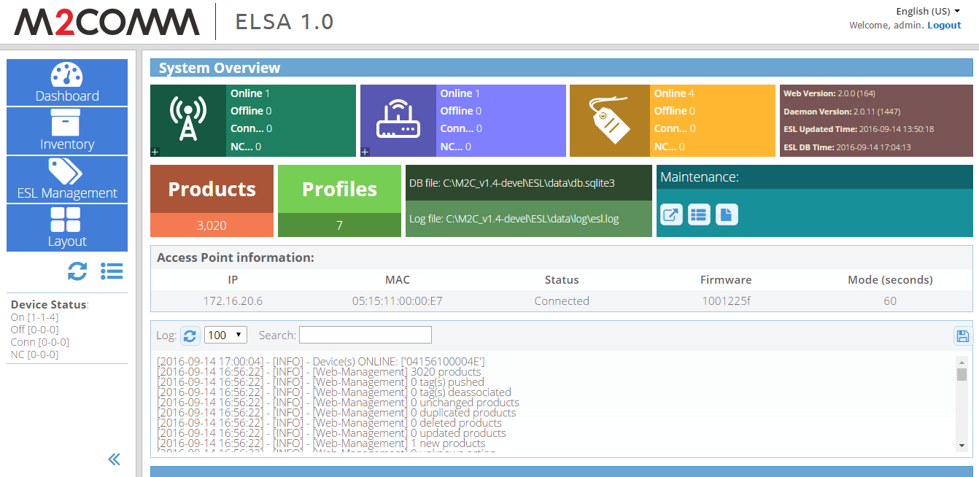

20

19

18

17

16

15

14

13

12

11

10

9

8

7

6

5

4

3

2

1. Language options
2. Logout ELSA web management system
3. Accessing dashboard page
4. Accessing inventory page
5. Accessing ESL management page
6. Accessing layout page
7. Checking ELSA system update
8. Accessing Job status page
9. Number of devices based on status
10. Hide left side navigation
11. Number of AP and its children
12. Number of RT and its children
13. Number of TAG and its children
14. System version
15. Number of products
16. Number of profiles
17. Database and log path
18. Access to maintenance page
19. AP information
20. ELSA Web Management log

### Inventory

Below is the inventory page explanation

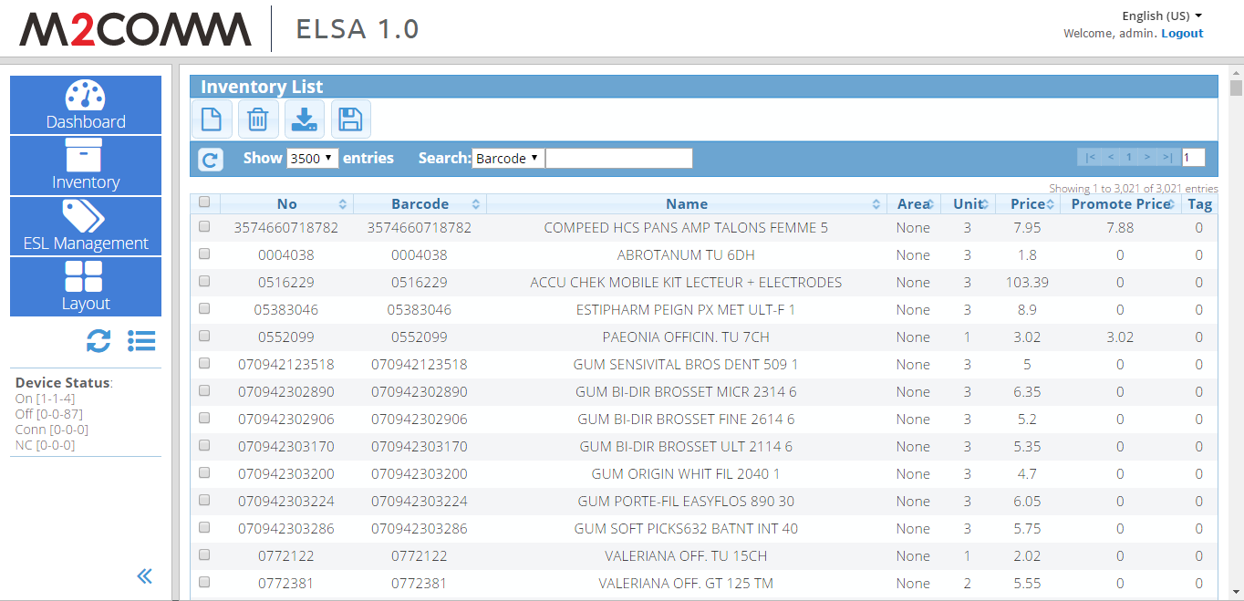

4

3

2

1

1. Access inventory page
2. List of inventory
3. Actions available for inventory
   1.  Add new inventory
   2.  Remove inventory
   3.  Import inventory
   4.  Backup inventory
4. Show and search options

### ESL Management

Below is the ESL management page explanation

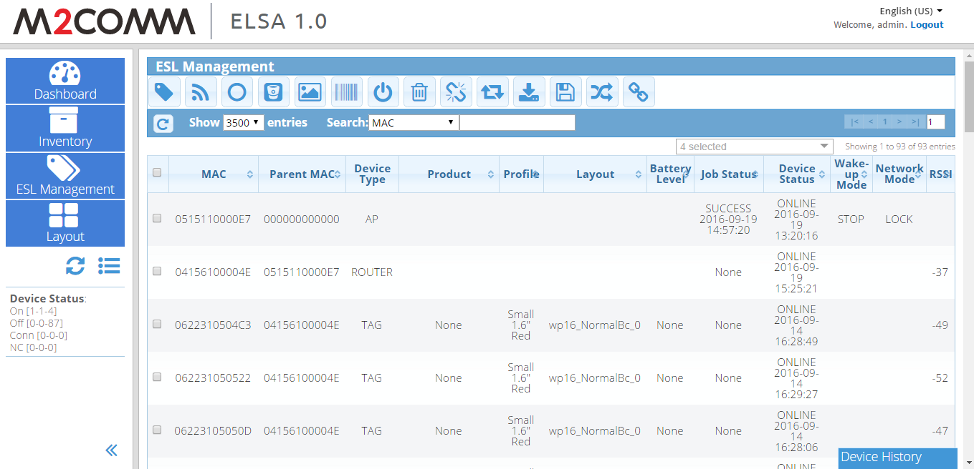

4

3

2

1

1. Access ESL management page
2. List of devices
3. Actions available for ESL
   1.  Push
   2.  Query
   3.  Reboot
   4.  Set battery level
   5.  Image push
   6.  Show barcode
   7.  Shutdown
   8.  Delete
   9.  Deassociate
   10.  Change wake-up mode
   11.  Import association
   12.  Export ESL
   13.  Sync web’s db to PostgreSQL
   14.  Go to barcode page
4. Show and search options

### Layout

Below is the layout page explanation

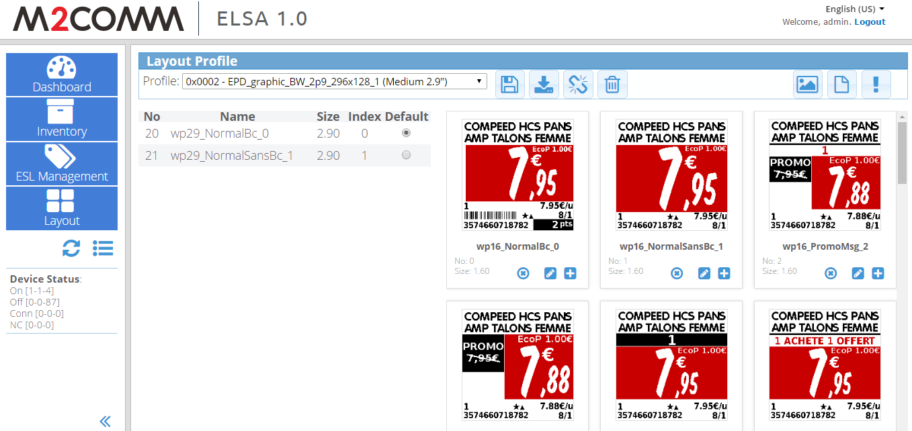

6

6

5

4

3

2

1

1. Access layout page
2. List of profiles
3. Actions available for profile – layout
   1.  Export profile, layout and its associations
   2.  Import profile, layout and its associations
   3.  Deassociate all layout from selected profile
   4.  Remove selected profile
4. All available layout
5. Actions available for layout
   1.  Generate all layouts preview
   2.  Add new layout
   3.  Remove all layouts
6. Actions available for specific layout
   1.  Delete layout
   2.  Edit layout
   3.  Associate layout to profile

### Installation Wizard – Device registration

Below is the installation wizard - device registration page explanation

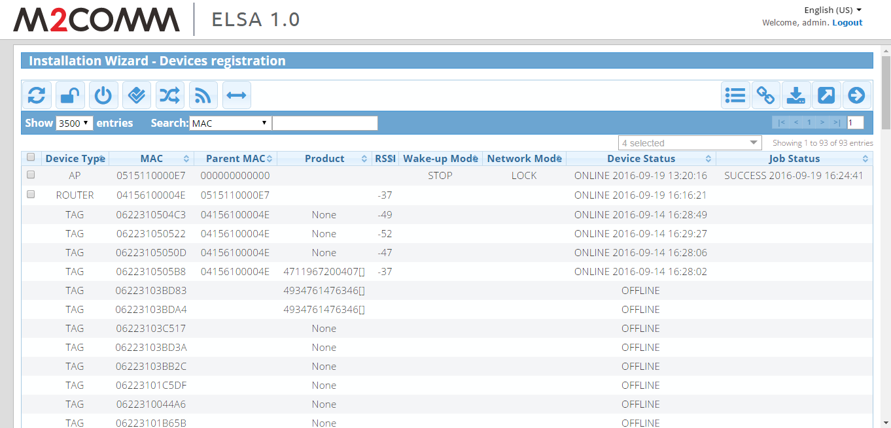

2

4

3

1

1. List of devices
2. Show and search options
3. Actions available for devices
   1.  Refresh table list
   2.  Unlock network
   3.  Stop wake-up mode
   4.  Confirm router
   5.  Get devices list from daemon
   6.  Query device
   7.  Get switch channel status
4. Actions related with system
   1.  Job status
   2.  Go to barcode association page
   3.  Import association
   4.  Send association list (to daemon)
   5.  Go to next page

### Installation Wizard – Waking-up tags

Below is the installation wizard – waking-up tags page explanation

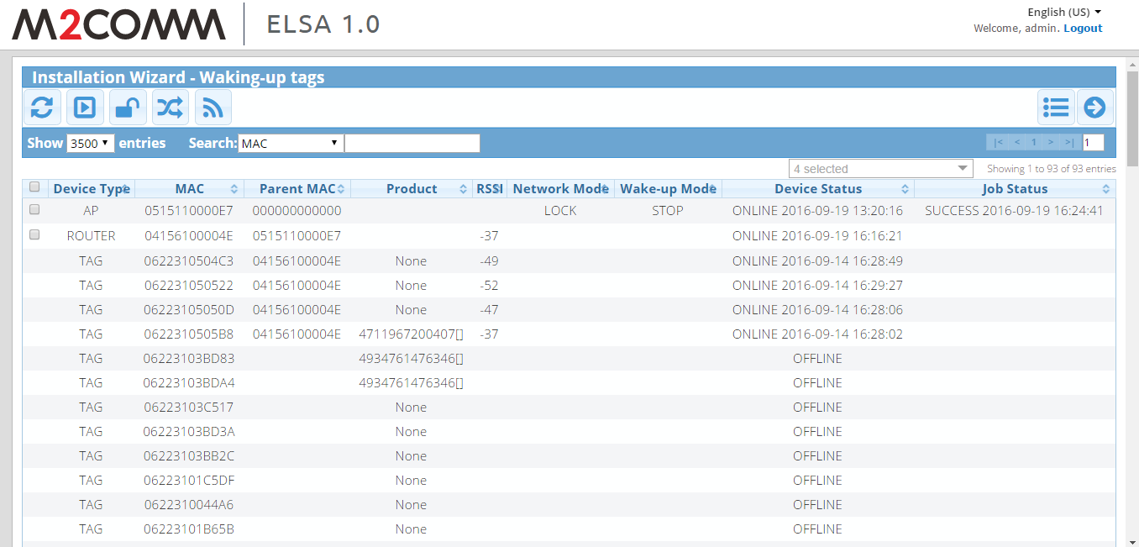

4

1

3

2

1. List of devices
2. Show and search options
3. Actions available for devices
   1.  Refresh table
   2.  Start wake-up mode
   3.  Unlock network
   4.  Get devices list from daemon
   5.  Query device
4. Actions related with system
   1.  Job status
   2.  Finish installation wizard

# Contact Information

|  |
| --- |
| **M2Communication, Inc. (M2C)**  4F-3, No. 32, Gaotie 2nd Rd,  Zhubei City, Hsinchu County, Taiwan  Tel: +886-3-657-8939  Fax: +886-3-657-6909  Email: support@m2comm.com |
|  |
| This document contains confidential information and is subject to the terms and conditions set forth in the Non-Disclosure Agreement between the Recipient Entity and M2Communication, Inc. (M2C) The information in this document is believed to be accurate in all respects at the time of publication but is subject to change without notice. M2Communication, Inc. assumes no responsibility for errors and omissions, and disclaims responsibility for any consequences resulting from the use of information included herein. Additionally, M2Communication, Inc. assumes no responsibility for the functioning of un-described features or parameters. M2Communication, Inc. reserves the right to make changes without further notice. M2Communication, Inc. makes no warranty, representation or guarantee regarding the suitability of its products for any particular purpose, nor does M2Communication, Inc. assume any liability arising out of the application or use of any product or circuit, and specifically disclaims any and all liability, including without limitation consequential or incidental damages. M2Communication, Inc. products are not designed, intended, or authorized for use in applications intended to support or sustain life, or for any other application in which the failure of the M2Communication, Inc. product could create a situation where personal injury or death may occur. Should Buyer purchase or use M2Communication, Inc. products for any such unintended or unauthorized application, Buyer shall indemnify and hold M2Communication, Inc. harmless against all claims and damages. |